

Scanquire User Manual
  - 3 July 2014

Introduction
The e-Docs USA Scanquire application is a plugin based TWAIN compatible scanning application. The main scanning interface has been standardized to make the scanning and editing process uniform for all document types. Each document type will have a separate plugin that will provide a custom interface for document archival and retrieval.

Application Interface

Main Toolbar
The main toolbar is used for selecting the active document type, creating, modifying, retrieving and saving documents.
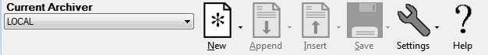

Thumbnail and Image Panels
The thumbnail panel is used for viewing and performing bulk operations on pages contained in the current document. The image panel is used for making changes to an individual image.
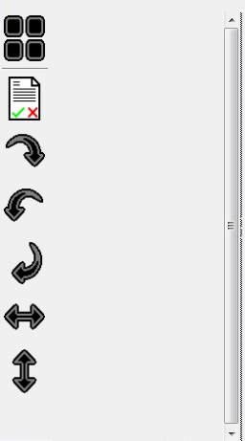  Thumbnail Panel | 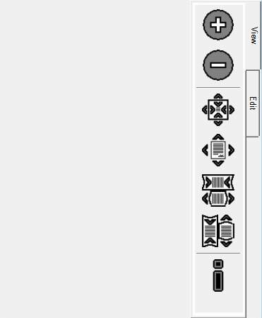  Image Panel

Getting Started
Launch the application by double-clicking the icon
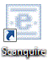

Scanning a New Document
- Prepare your document for scanning.
  - Remove all bindings (staples, paper clips, etc).
Typical scanners are only capable of reading a single page at a time. If you are using a sheet fed scanner, the scanner will pull each page through one by one. If pages are bound together, the scanner will grab multiple pages, but will not create an electronic image for all of the pages. Bindings can also cause paper jams, and, in extreme cases, can scratch the scanners lens. Scratches in the scanner's lens will cause lines to appear in future scanned images. Repairing a lens can be very costly and can take the scanner out of operation for multiple days. For these reasons, it is absolutely critical that all bindings be removed prior to scanning.
  - Insert any needed document separator sheets.
- Prepare the scanner for scanning.
  - Ensure the scanner is connected and turned on.
  - Ensure the scanner is clean.
Dirty scanners can produce poor quality images.
- Select the document type from the Current Archiver drop-down menu.
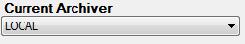
Always ensure that you have the correct archiver selected. Failure to do so can result in documents being archived incorrectly.
- Click the New Document icon and select New From Scanner

- Enter any required indexing information. The indexing information will depend on the selected archiver. Some archivers will not require any input.
- Select the scanner and scanning settings and click OK. Some archivers will pre-define these options and will not prompt for input.
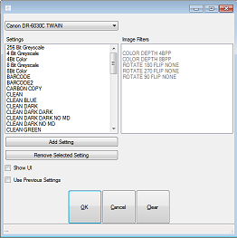
- Review the pages as they are scanned in. As the application retrieves the images from the scanner, thumbnails of the images will be displayed in the Thumbnail Panel. You should be able to detect most image quality issues (wrong settings, dirty scanner) by viewing these thumbnails. If you notice anything wrong, you can pull the remaining pages from the scanner and make any needed adjustments before re-scanning.

Opening an Existing Document
- Click the New Document button and select New From Archive or New From Local File.
- Using the selected archiver’s interface select the file to open.

Editing an Open Document

Selecting Images
- Using the mouse, click on an image thumbnail in the Thumbnail Panel. You can select multiple pages by holding down the ctrl key while clicking. You can select multiple pages in a row by clicking on the first page, then holding down the shift key and then clicking on the last page. 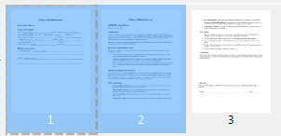

Adding Images
- Click the Append button and select the source of the additional pages


Inserting Images
- Select a single image from the Thumbnail Panel to insert the pages in front of.
- Click the Insert button and select the source of the additional pages.


Adding Command Images
Command images allow you to add comments or special commands to a document. The commands are typically encoded in barcodes on the image and will depend on the selected archiver.
- Click Append or Insert button and select From Command
- Fill in the details of the command image.
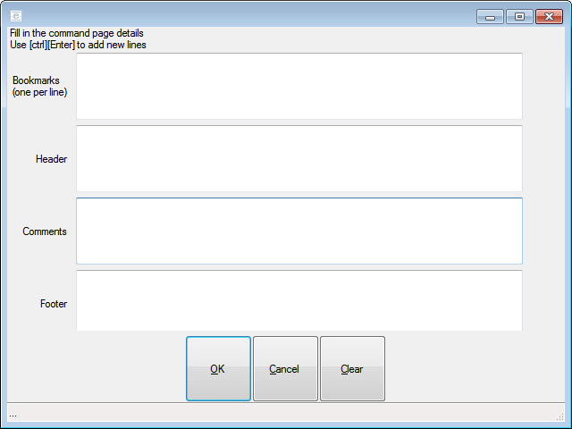

Removing Images
- Select the images to be removed.
- Click the Check/Uncheck Images icon.

- The selected images will now be flagged for removal upon saving. Flagged images will be displayed with a red border.
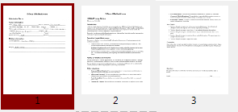
- If you accidentally flag an image for removal, you can un-flag it by selecting it and clicking the Check/Uncheck Images icon again.

Rotating and Flipping Images
 | Rotate the selected images to the right by 90 degrees
 | Rotate the selected images to the left by 90 degrees
 | Rotate the selected images by 180 degrees
 | Flip the selected images horizontally.
 | Flip the selected images vertically.
 | Rotate the selected images 180 degrees and flip horizontally.

Viewing Images
The last selected image will be displayed in the Image Panel.

Zooming
The active image can be re-sized using the zooming buttons in the Image Panel Toolbar. Zooming only affects the way the image is displayed; it will not have any permanent affect on the image file.
 | Increase the size.
 | Decrease the size.
 | Scale the image so that the entire image is visible in the Image Panel.
 | Scale the image to its full size.
 | Scale the image so the width matches the width of the Image Panel.
 | Scale the image so that its height matches the height of the Image Panel.

Saving the Active Document
- Make sure you have the correct archiver selected.
- Click the Save button and select the destination.

- Enter any required indexing information. The specific information required depends on the selected archiver. Some archivers do not require any input.

Local Archiver
The Local filesystem archiver is a special case archiver designed to simplify access to the local filesystem. You do not have to select the archive from the archive list to store and retrieve documents to and from the local filesystem. The New, Append, Insert and Save buttons all have options to store and retrieve directly to and from the local filesystem archive.

Troubleshooting

Contacting Support
Support is available by calling (406) 723-8721 or emailing support@edocsusa.com.
When contacting support, please make a note of the following:
- What the problem is.
- The steps that were taken prior to the error occurring.
- Text of all error messages received.

Scanner Issues
Poor Image Quality | Ensure the scanner is clean.  Ensure the correct settings are being used.
Scanner Malfunction | Ensure the scanner is plugged in and turned on.  Clear any error messages and try again.  Turn the scanner off, wait 30 seconds, turn it back on and try again.

